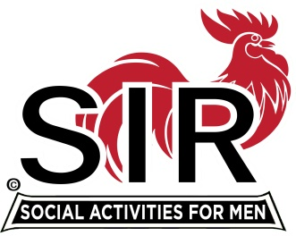
Las Trampas Branch 116
BEC Meeting Agenda
May 18th , 2020, 8:30 AM
The Mission of SIR is to enhance the lives of our members through fun activities, events and luncheons – while making friends for life.

8:30 Coffee Available !!!

- Call to order; Secretary confirm a quorum
- Secretary – Fred Schafer – Approval of April minutes
- Treasurer – Alan Fitzgerald:
- Activities report: Fred Wachowicz
Bernie Wrobleski (Golf)
5) Big SIR report – Michael
- Virtual mtgs (Davy Harris)
- Member phone calls (Roger Craig)
- Jerry Hicks
- Little SIR report
- Outside vendors (Warriors)
- AOB

- Date for next meeting?

